**First of all I have created project on start.spring.io each for student and college services, like shown in the screenshot below**

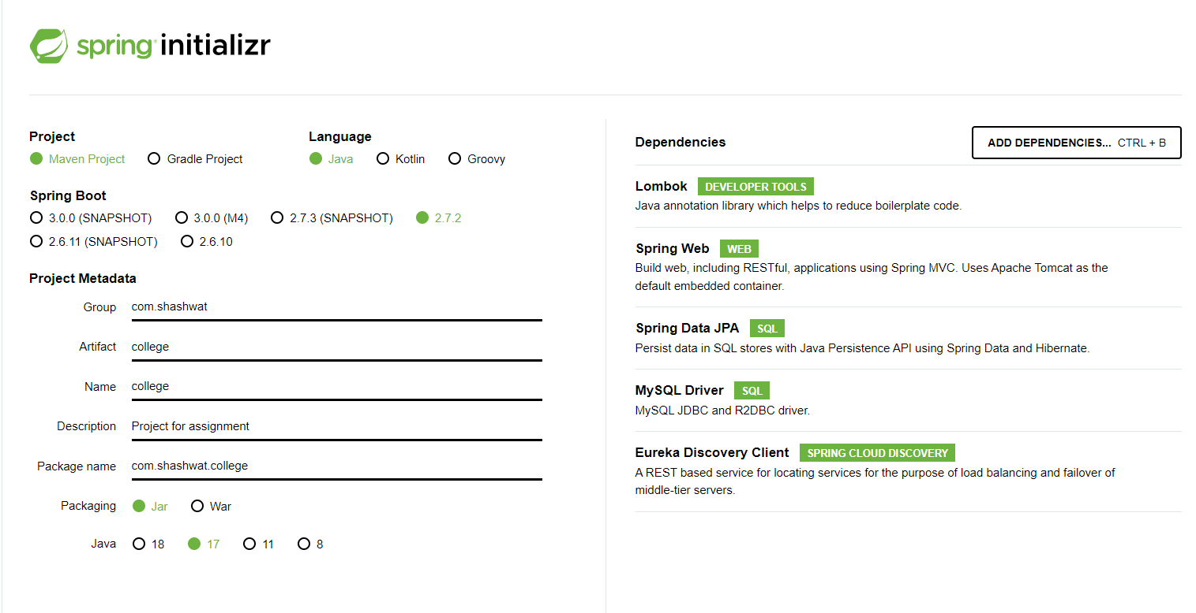

**the application.properties files for both of them look like as shown below**

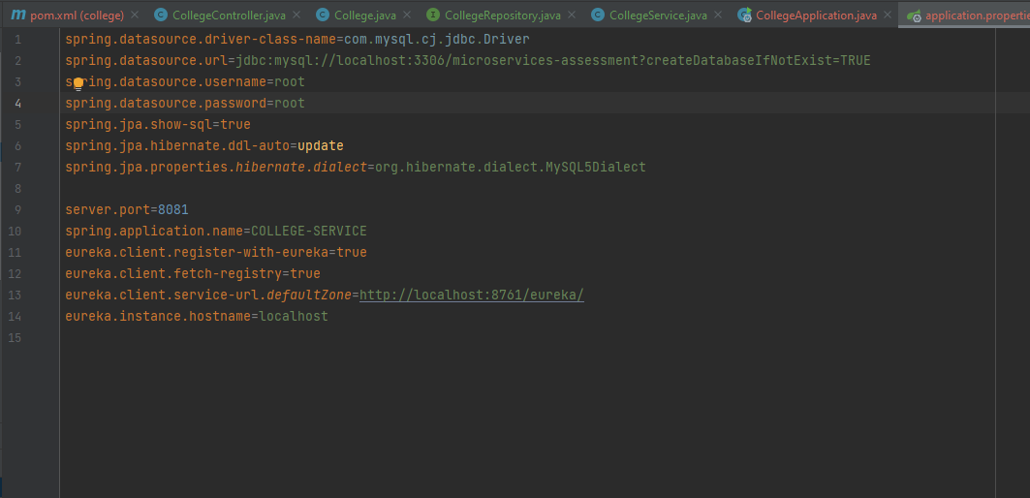

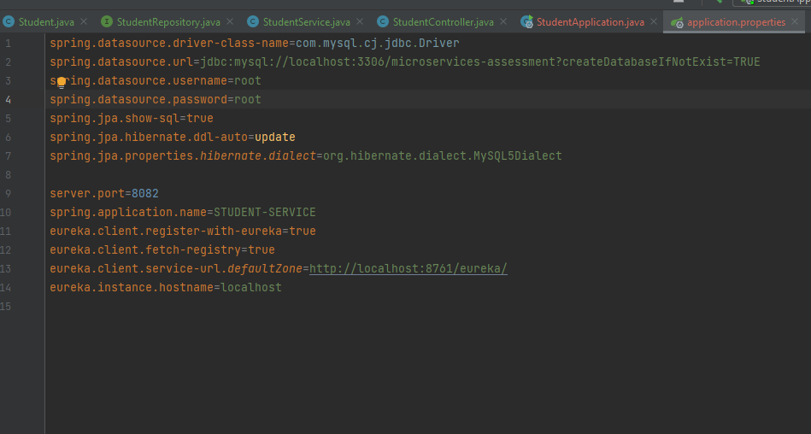

**Then I have create project for service-registry and api gateway, the init for api gateway looks like this**

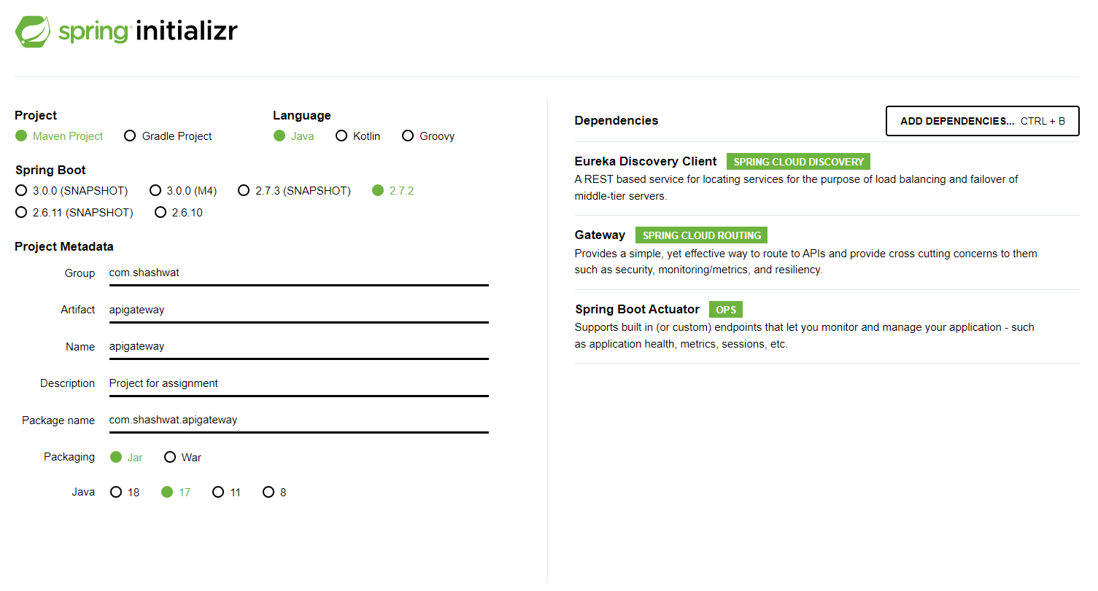

**the application property file for registry looks like as shown in the screenshot below, we have used port 8761 in this case**

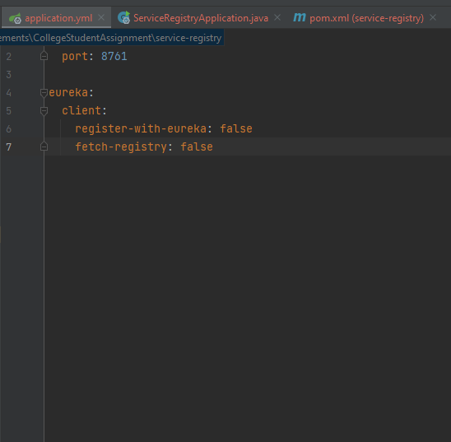

**finally, I have defined the routes for the apis in the application properties of api gateway as shown below.**

**The api gateway runs on port 9191, which will route the calls based on the endpoint to Appropriate service.**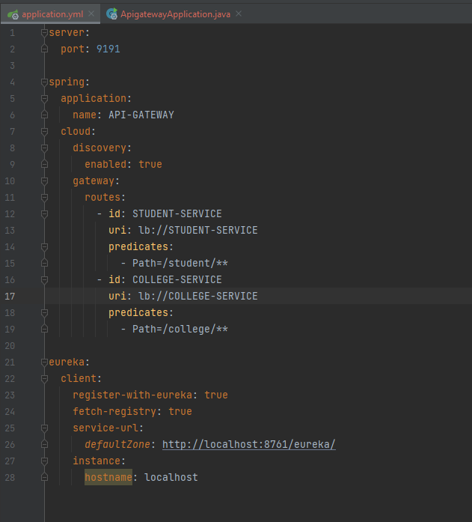

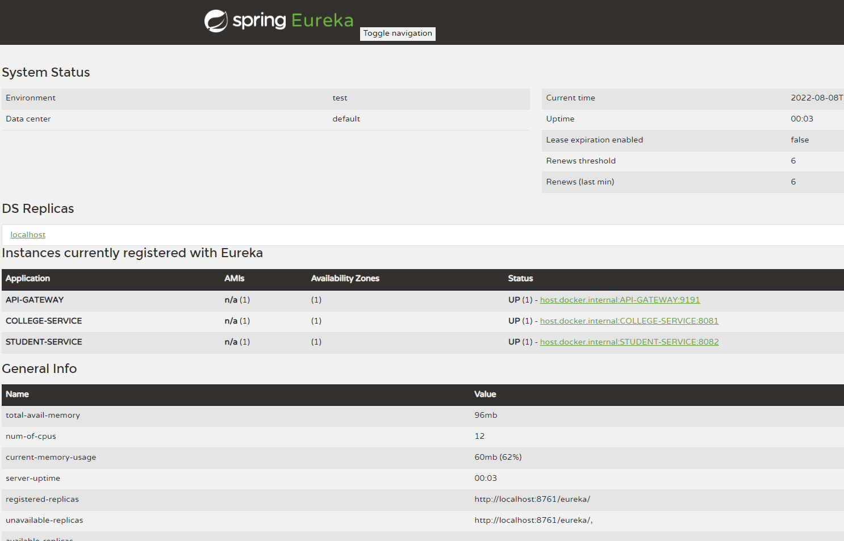

**I have created college and students using postman, as shown below.**

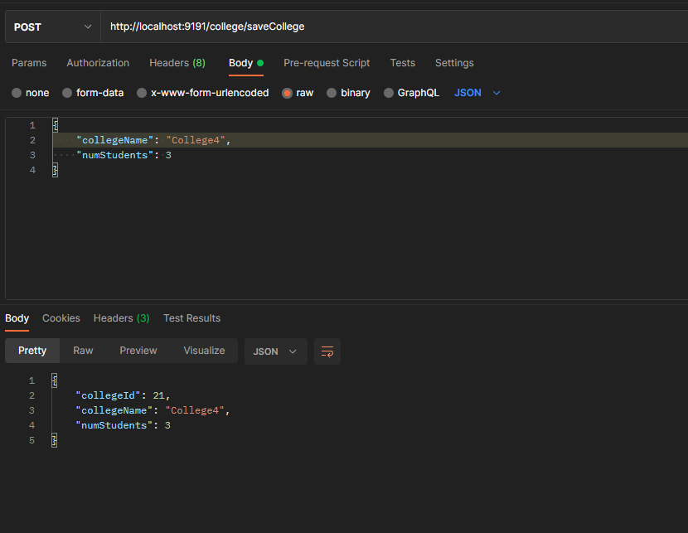

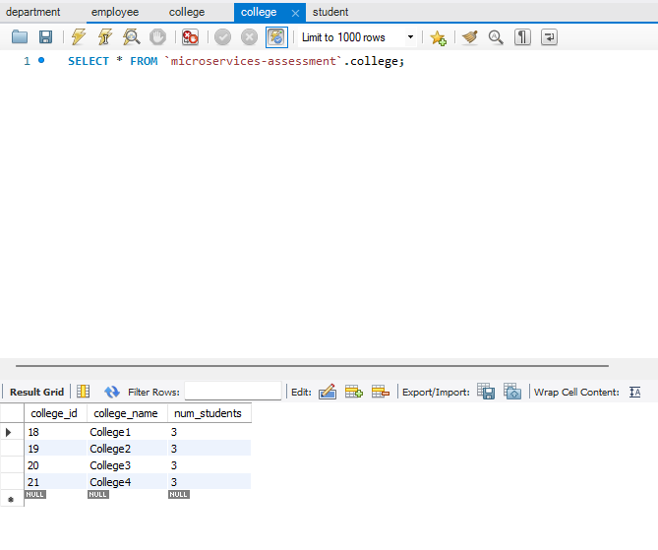

**Saved student without the college id, as we are fetching the college id in the student service using college microservice call, and we are getting the fetched college id in response.**

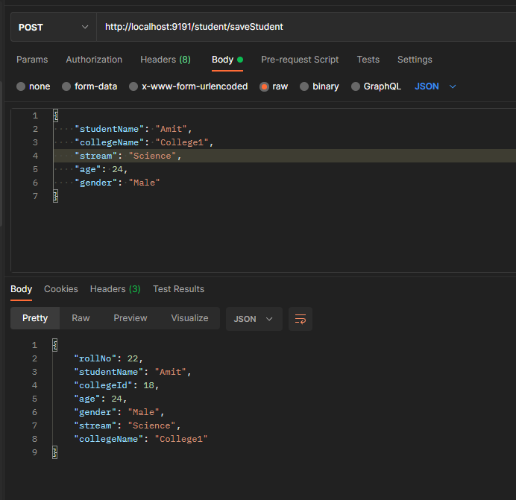

**The college VO for this is as below in the student microservice**

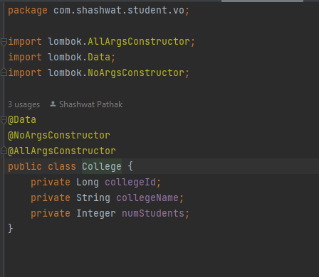

**All the saved students in the db as shown below**

**Displaying all colleges and it’s students info with name in ascending order**

**Now, as in the question, we display all student of a stream based on age in descending order**

**For commerce stream, descending by age-**

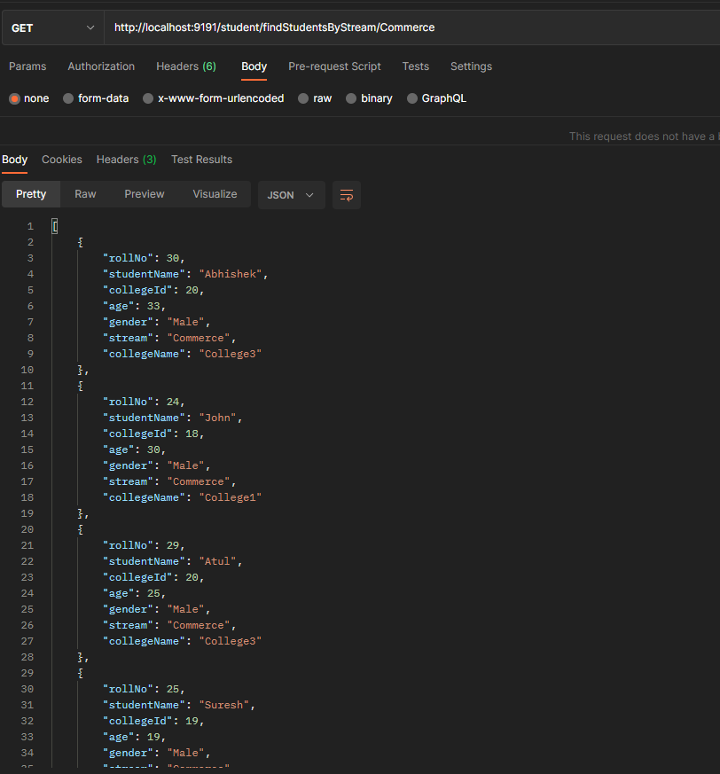

**Similarly for arts stream**

**­­**

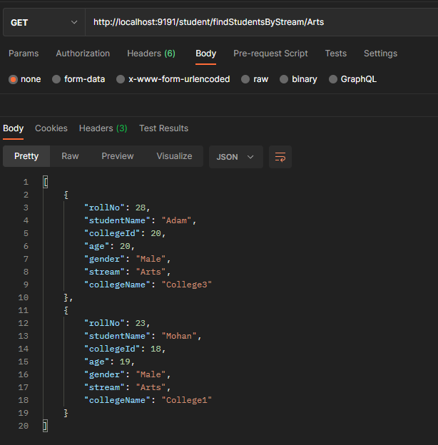

**And for science stream**



